# MFA2020 Analysis of Financial Statements Assignment #1

**Part 1: Revenue recognition**

Microsoft distributes its products primarily through original equipment manufacturers, corporate licences and as retail packaged products.

At one point, Microsoft’s corporate licensing program accounted for over 50% of Microsoft’s turnover. The corporate licences used to be typically for a 2-year period and required the customer to forecast the number of units to acquire. The unit price under the agreement depended upon the number of units forecast to be purchased, with larger orders enjoying lower unit prices. Upon signing the agreement, Microsoft shipped out a CD-ROM copy of the licensed software. Although payment for the licence could be made at the signing of the agreement, most customers paid Microsoft on a monthly basis based on the number of units installed in the previous month. The customer was required to install at least 25% of the units within 6 months of signing the agreement and at least 50% within 12 months. Failure to reach these targets increased the unit price under the licence.

Microsoft had several alternative revenue recognition policies for recording the fees from corporate licences:

* *Method I* Revenue is recognised when CD-ROM is shipped, based on forecast number of units to install. Any difference between forecasts and the actual installations are adjusted as “sales returns” at the end of the agreement.
* *Method II* Revenue is recognised when the customer informs the actual number of installations.
* *Method III* Revenue is recognised when cash is received from the customer.

Assume that total units ordered under the corporate licence program were 350 million, at a unit price of $10. The total number of CD-ROMs shipped was 175,000. The cost of each CD- ROM is $2. Of these, customers had reported installing 250 million and had paid $2bn towards these installations. Ignore impact of agreements signed in prior years.

* 1. Calculate the sales figure, cost of sales and cash receipt.  
       
     Cost of sales are 2$ * 175,000 (shipped) = 350,000$ for each method.  
     Cash receipt is 2 bn $ for each method.  
     Only sales figures vary among methods and is:  
     Method I: 350m * 10$ = 3.5 bn $ (as 350m orders were forecasted)  
     Method II: 250m * 10$ = 2.5 bn $ (as 250m orders were reported)  
     Method III: = cash received = 2 bn $ (revenue recognized equals cash received from customers)
  2. Analyse the effect of each alternative policy on the financial statements of Microsoft in the current and future years.  
     Method I: This method is aggressive method as compared to others, reports the highest number of sales figures. There exist lags between actually received revenue and revenue recognized in Income Statement. One concern is that customers are keen to overestimate their orders in order to take advantage of lower per unit price. In reality, they won’t make stated number of orders, giving rise to discrepancy between reported and actual revenue. So, in future, Microsoft would need to write off unearned revenue due to overestimation of their customers. In past year, number of estimated orders was 350m whereas only 250m were installed, 30% difference.  
       
     Method II: This method is not as aggressive as Method I, recognizing only actually installed number of orders, avoiding problem of customers overstating their orders. Actual number of orders stated by customers now is same as number of orders actually paid and installed.  
       
     Method III: On the contrary to Method I, this method can actually underestimate earned revenue. This is very conservative accounting method. If some customers pay by credit, this revenue won’t be recognized as there is no cash received, but actually Microsoft will get this revenue, as order has been installed.
  3. Discuss whether each revenue recognition policy meets the key GAAP requirements with regard to:
     + Completion of earnings process. i.e., all rewards and risks of ownership should be transferred to the buyer.  
         
       Method I: There is no completion of earnings process. Microsoft bears risks that neither price nor quantity of orders will be the same as predicted by customers.   
         
       Method II: The price and quantity are certain, so all rewards and risks of ownership are on buyers, not Microsoft.  
         
       Method III: As cash receipt matches recognized revenue, there is no risk for Microsoft. The whole earnings process is certain.
     + Assurance of payment. i.e., there should be reasonable certainty about the consideration to be received.  
         
       Method I: There is no certainty, as customers estimates are taken into account, which are likely to be overestimated in order for them to secure lower per unit price. So there is uncertainty about both price and quantity of orders.   
         
       Method II: Yes, shipped orders will be paid, so there is certainty about recorded revenue (although some of it may be paid on credit and some in cash terms).  
         
       Method III: Yes, there is total certainty that recorded amount is received.

# Part 2: Cost Capitalisation

On the following page you will find a five-year financial summary for the Bayer Group, a large German pharmaceutical firm. Assume the useful life of an R&D asset is five years and that R&D expenses are incurred in the middle of the year. Assume that for tax purposes R&D is expensed (giving rise to a deferred tax liability when R&D asset is recognised). In its 2007 balance sheet Bayer reports €4,346 mil for deferred tax liability. Based on this information you are required to calculate:

1. the 2007 end-of-year balance of goodwill and other intangible assets adjusted for the capitalisation of R&D expense;
2. the 2007 end-of-year balance of deferred tax liability adjusted for the capitalisation of R&D expense;
3. the 2007 income (loss) before income taxes adjusted for the capitalisation of R&D expense. Assume R&D expense in 2002 was €2,187 mil; and
4. the income (loss) after taxes adjusted for the capitalisation of R&D expense.

## Assume tax rate is 30%. Please round up to one decimal place.

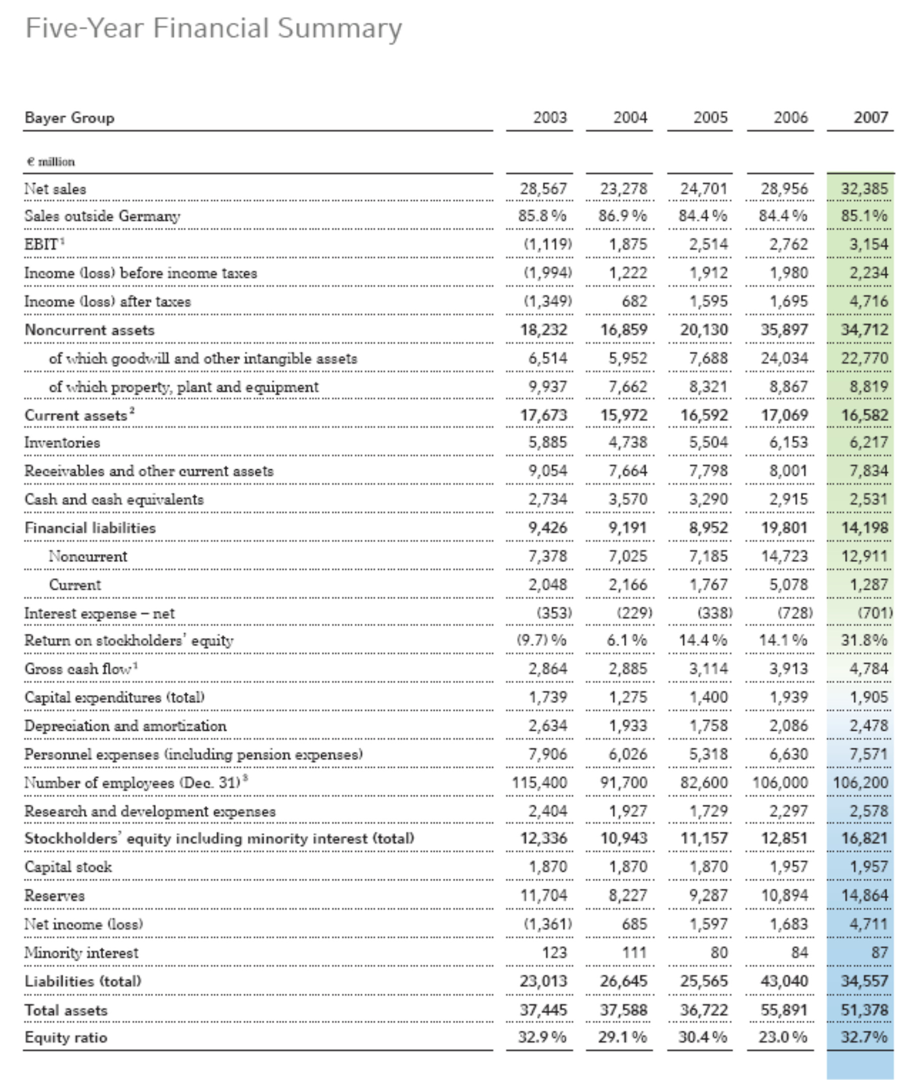

**Part 3: Long-Term Assets**

Use the attached balance for the year 2000 to answer the following questions about long-term assets.

***For the following questions, assume that total depreciation expense for the NYTimes during 2000 was $155,000.***

1. How much did the NY Times originally pay for all the buildings and equipment that it owned at December 31st, 2000?
2. Assuming that no land was sold during the year 2000, how much did the NY Times pay to purchase additional land during the year?
3. Assume that the NYTimes had purchased $185,300 in additional equipment during the year. Also assume that the only thing that the NYTimes sold was one piece of printing equipment for $191,171 in cash.
   1. How much did the NYTimes originally pay for the piece of equipment that was sold?
   2. At the time of sale, what was the accumulated depreciation on the piece of equipment that was sold?

|  |  |  |
| --- | --- | --- |
| **CONSOLIDATED BALANCE SHEETS** | December 31, | December 26, |
| (In thousands) | 2000 | 1999 |
| **ASSETS** |  |  |
| **CURRENT ASSETS**  Cash and cash equivalents | $ 69,043 | $ 63,861 |
| Accounts receivable (net of  allowances: 2000 - $44,169; 1999 - $39,749) | 341,863 | 366,754 |
| Inventories | 35,064 | 28,650 |
| Deferred income taxes | 62,939 | 53,611 |
| Other current assets 101,857 102,032 | | |
| **Total current assets** | **610,766** | **614,908** |
| **INVESTMENT IN JOINT VENTURES** | **107,320** | **121,940** |
| **PROPERTY, PLANT AND EQUIPMENT**  Land | 72,228 | 67,149 |

Buildings & Equipment 2,216,046 2,128,014

**Total - at cost 2,288,274 2,195,163**

Less accumulated depreciation 1,081,114 976,767

|  |  |  |
| --- | --- | --- |
| **Property, plant and equipment - net** | **1,207,160** | **1,218,396** |
| **INTANGIBLE ASSETS** | **1,681,433** | **1,540,558** |
| - | | |
| **Total** | **$3,606,679** | **$3,495,802** |
| **LIABILITIES AND STOCKHOLDERS' EQUITY** |  |  |
| **CURRENT LIABILITIES** |  |  |
| Commercial paper outstanding | $ 291,251 | $ -- |
| Accounts payable | 178,302 | 191,706 |
| Accrued payroll and other related liabilities | 318,088 | 298,810 |
| Unexpired subscriptions | 87,130 | 80,161 |
| Current portion of long-term debt 2,599 102,837 | | |
| **Total current liabilities** | **877,370** | **673,514** |
| **LONG-TERM DEBT** | **1,448,146** | **1,373,630** |
| **Total liabilities** | **2,325,516** | **2,047,144** |
| **STOCKHOLDERS' EQUITY** |  |  |
| Common stock of $.10 par value | 16,738 | 17,882 |
| Retained earnings | 1,467,103 | 1,600,743 |
| Common stock held in treasury, at cost  Accumulated other | (198,858) | (173,137) |
| comprehensive income (loss), net of income tax: (3,820) 3,170 | | |
| **Total stockholders' equity** | **1,281,163** | **1,448,658** |
| **Total** | **$ 3,606,679** | **$ 3,495,802** |

**From Footnote #1: SUBSCRIPTION REVENUES AND COSTS**

Proceeds from subscriptions and related costs, principally agency commissions, are deferred at the time of sale and are included in the Consolidated Statements of Income on a pro rata basis over the terms of the subscription.

## Reminder! Assume depreciation expense for the year is $155,000.